HALLOWEEN
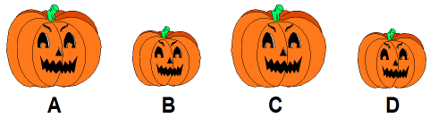
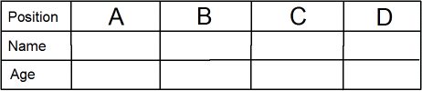
Puzzle Choice
Four friends aged 10,11,12 and 13 have each made a Halloween lantern. From the
picture and clues, can you work out who made each lantern and how old they are?

1. Lantern B was made by a 10 year old boy.

2. Lantern A was made by Natalie who isn't the oldest.

3. Justin made one of the big lanterns.

4. Melissa's lantern is pictured immediately next to the one made by the 12 year old.

5. One of the friends is named Tim.

Playing Instruments

Three friends Eddie, Eric and Emma are learning to play different musical instruments. From the clues see if you can work out the ages (9,10,11) and the different instruments they are playing.

1. Eddie is older than the friend who is learning to play the violin but younger than the friend who is learning to play the trumpet.
2. Emma is younger than Eric.
3. One of the friends is learning to play the drums.

Name Age Instrument

