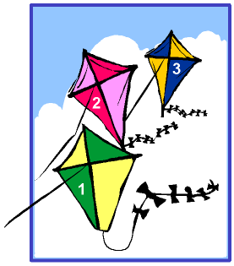
It's a windy day and three kids are in
the park flying their kites. Each kid
has a relative to help them.

Can you work out who owns which kite,
their age (9, 10, 12) and who they are with?

Look at the picture and the clues and fill in
the answer box where you can. Then read
the clues again to find the answer.
1. Debbie's kite is number 2 and she is a year younger than the kid who is with
their grandfather.

2. David is the oldest. His kite is lower than the one belonging to the kid who is
with their brother.

3. One of the kids is Darren but is he with his father?
