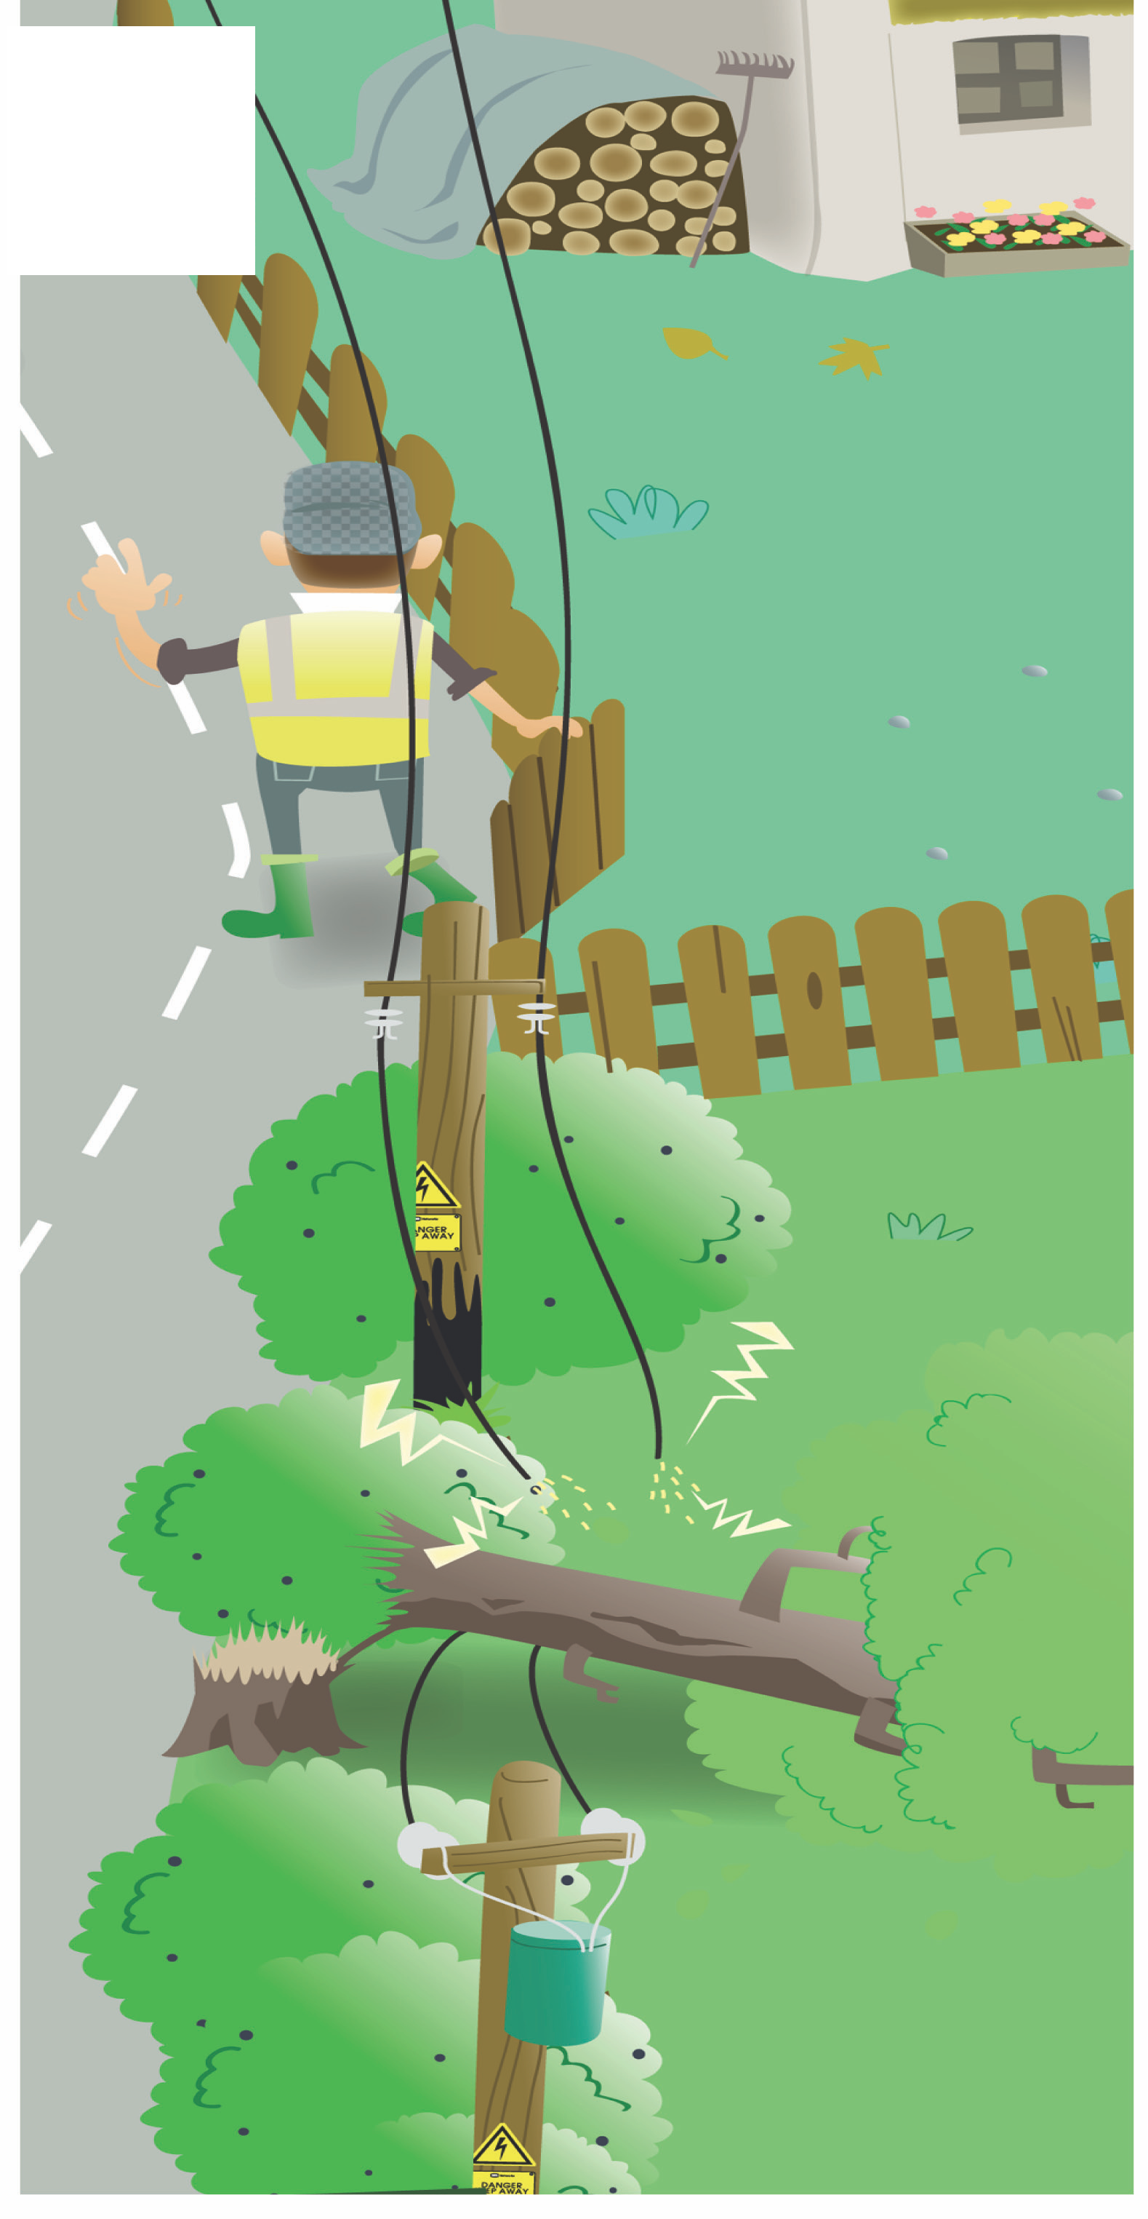

Farm and Countryside Safety Week
Electricity
Electricity
1
We should never climb an electricity pylon or electricity pole. Even if you do not touch the power lines, the electricity could jump through the air and electrocute you. Electricity sub-stations contain dangerous equipment and should never be entered. Tell an adult if something belonging to you falls through the fence.
Look out for overhead power lines in stormy weather, electrical wires may fall in the farmyard or in the fields. Do not go near fallen wires. Tell an adult or call ESB Networks on 1850-372-999.

Remember: Touching or coming close to electric wires can kill. Keep away from fallen wires.

Farm and Countryside Safety Week

Bulls
2 The male of many farm
animals can act in aggressive,
unpredictable and dangerous ways. One of the most dangerous animals found on the farm is the bull. Many lives have been lost due to sudden bull attacks. You should always treat all farm animals with respect. Do not annoy or taunt a bull in any way as it could attack you. The farmer will dehorn the
bull at a young age as horns can grow very big and become dangerous. The farmer also places signs on a field where a bull
is present as a warning to people passing by.

Remember: Never enter a ﬁeld where there is a bull it could cause serious harm

Farm and Countryside Safety Week

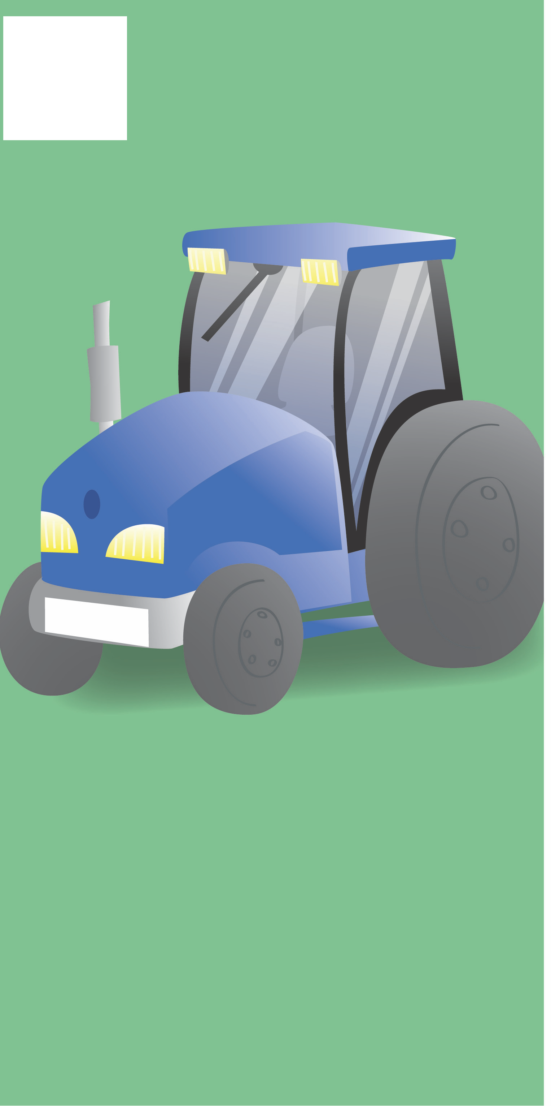Tractor Safety
Tractor Safety
3 Machines like tractors and trailers can be dangerous when they are
moving.

Your arm, leg or your clothes could very easily get trapped in the wheels so stay safe.

It is very dangerous to stand on a tractor as you might fall under it while moving. Never ride on high loads on a trailer or on the
drawbar of a trailer. Children under
14 years of age should not be allowed to drive tractors.

Remember: Always look out for the farmer when he/she is driving a tractor.

Farm and Countryside Safety Week
Be Safe Around Silage/Slurry Pits
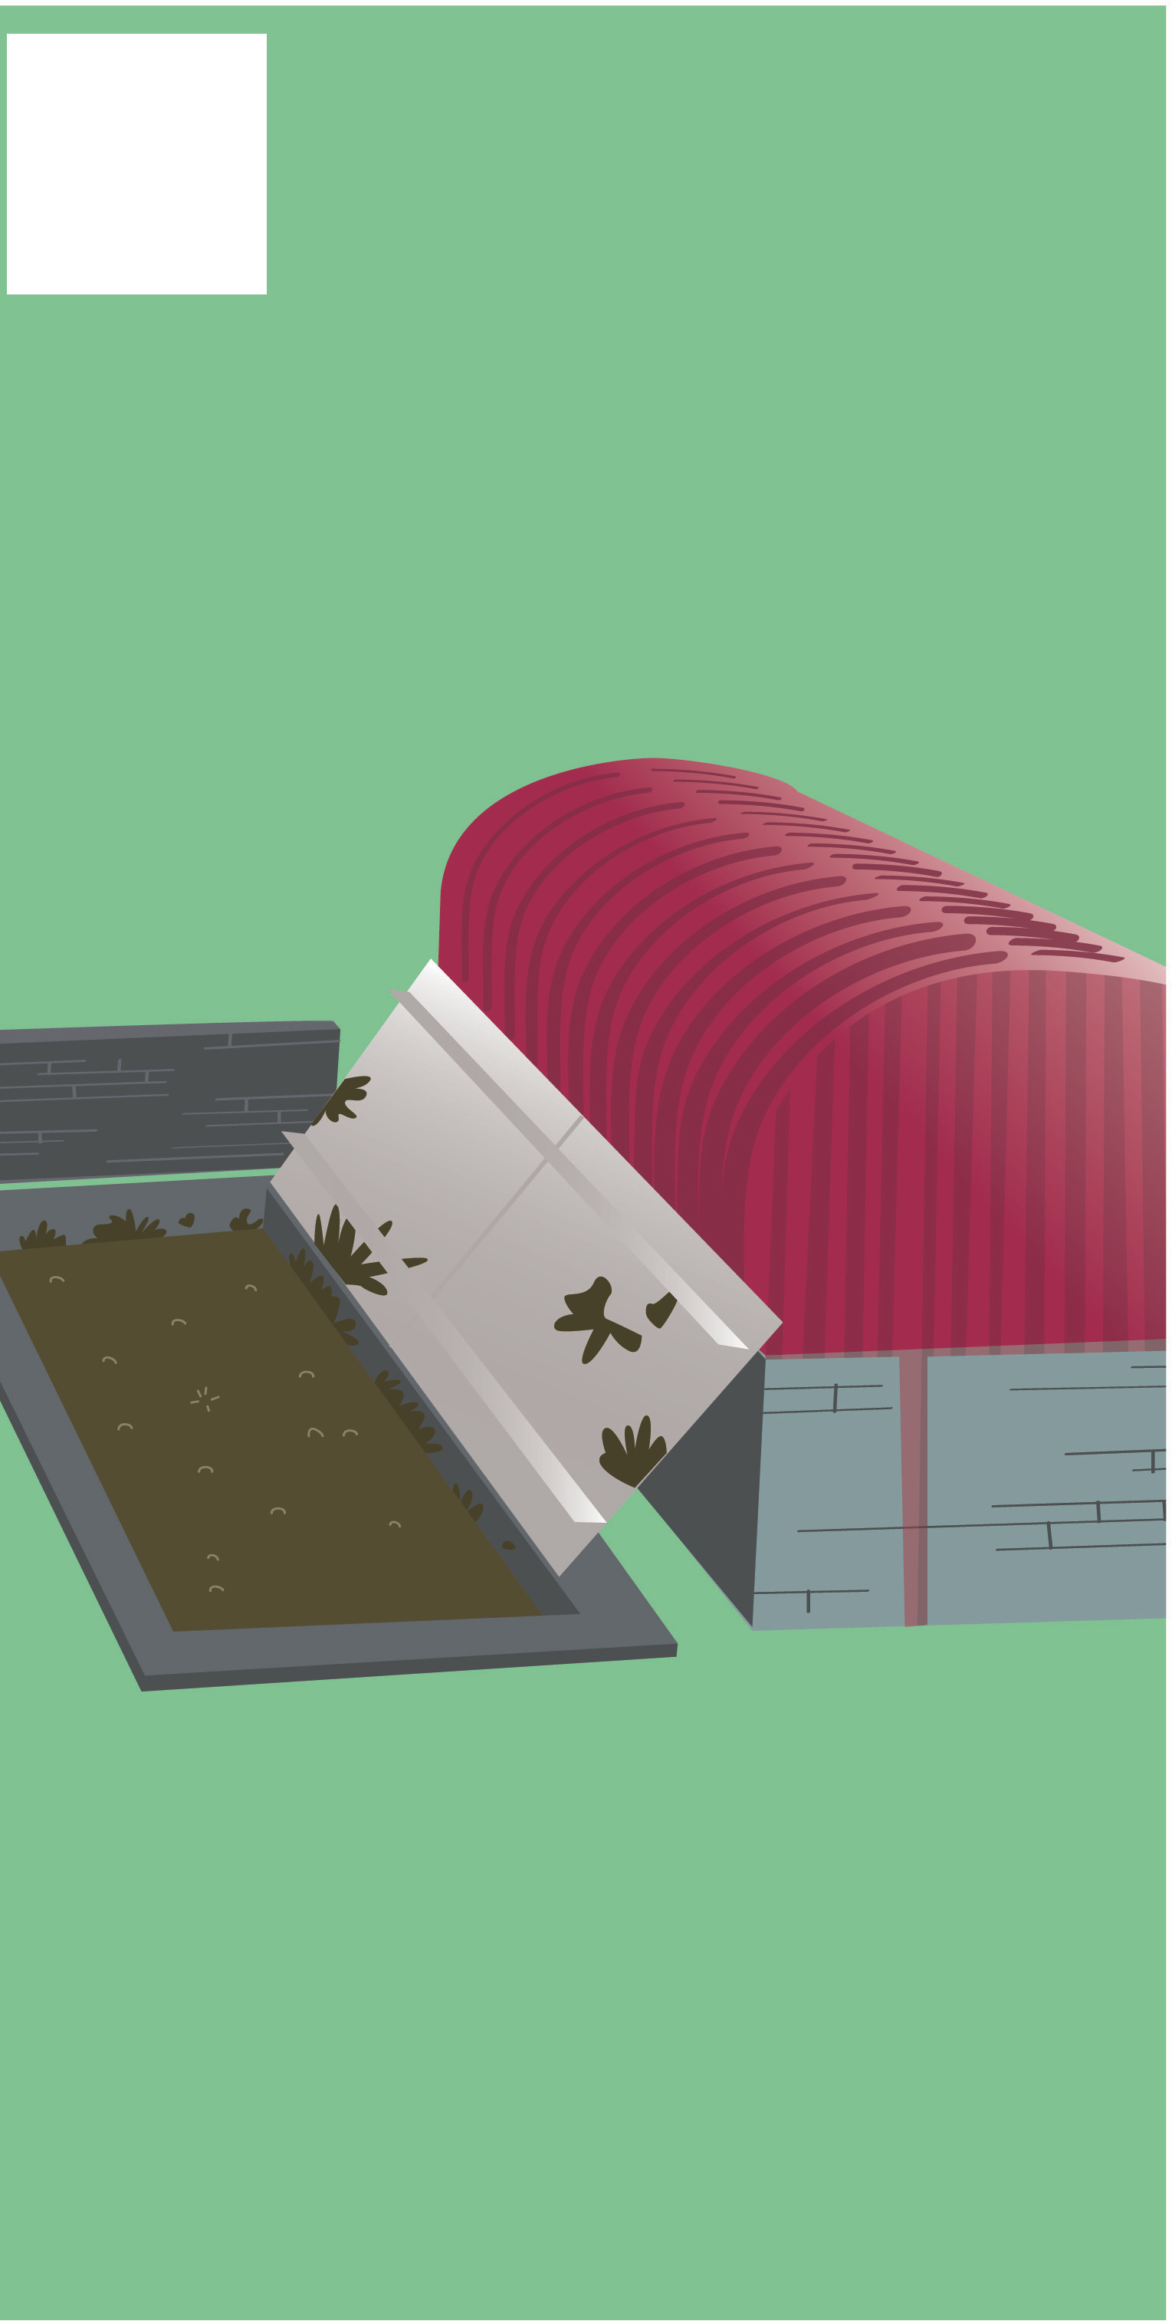Be Safe Around Silage/Slurry Pits
4

If you live on or are visiting a farm you should ask the farmer if there is a silage or slurry pit. The farmer uses silage and slurry for to keep crops on the farm healthy.

Do not walk, play or stand too close to either of these as they can be deep and very dangerous. If you fall into a slurry/silage pit you can easily drown. The farmer keeps slurry tanks covered or fenced off to
keep children out of and away from danger.

Remember: If something belonging to you falls into a slurry pit tell an adult. Do not try to get it out.

Farm and Countryside Safety Week
Playground
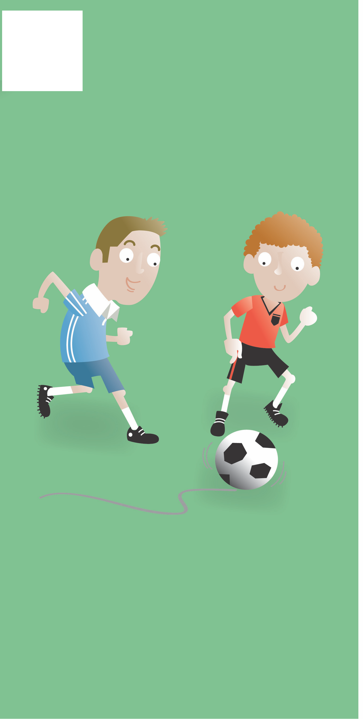Playground
5 The farm is an exciting and interesting place to visit. However
some areas of the farm are very dangerous for children. The
farm is not a playground and we should not treat it like one. When we want to play on the farm we should ask the farmer for a safe place to play. Never wander
away from this area. Be careful not to play in fields as animals could be grazing there. Do not play in sheds as there could be dangerous equipment stored there.

Remember: Always listen to the farmer and make sure to stay away from places you are not allowed to go.

Farm and Countryside Safety Week

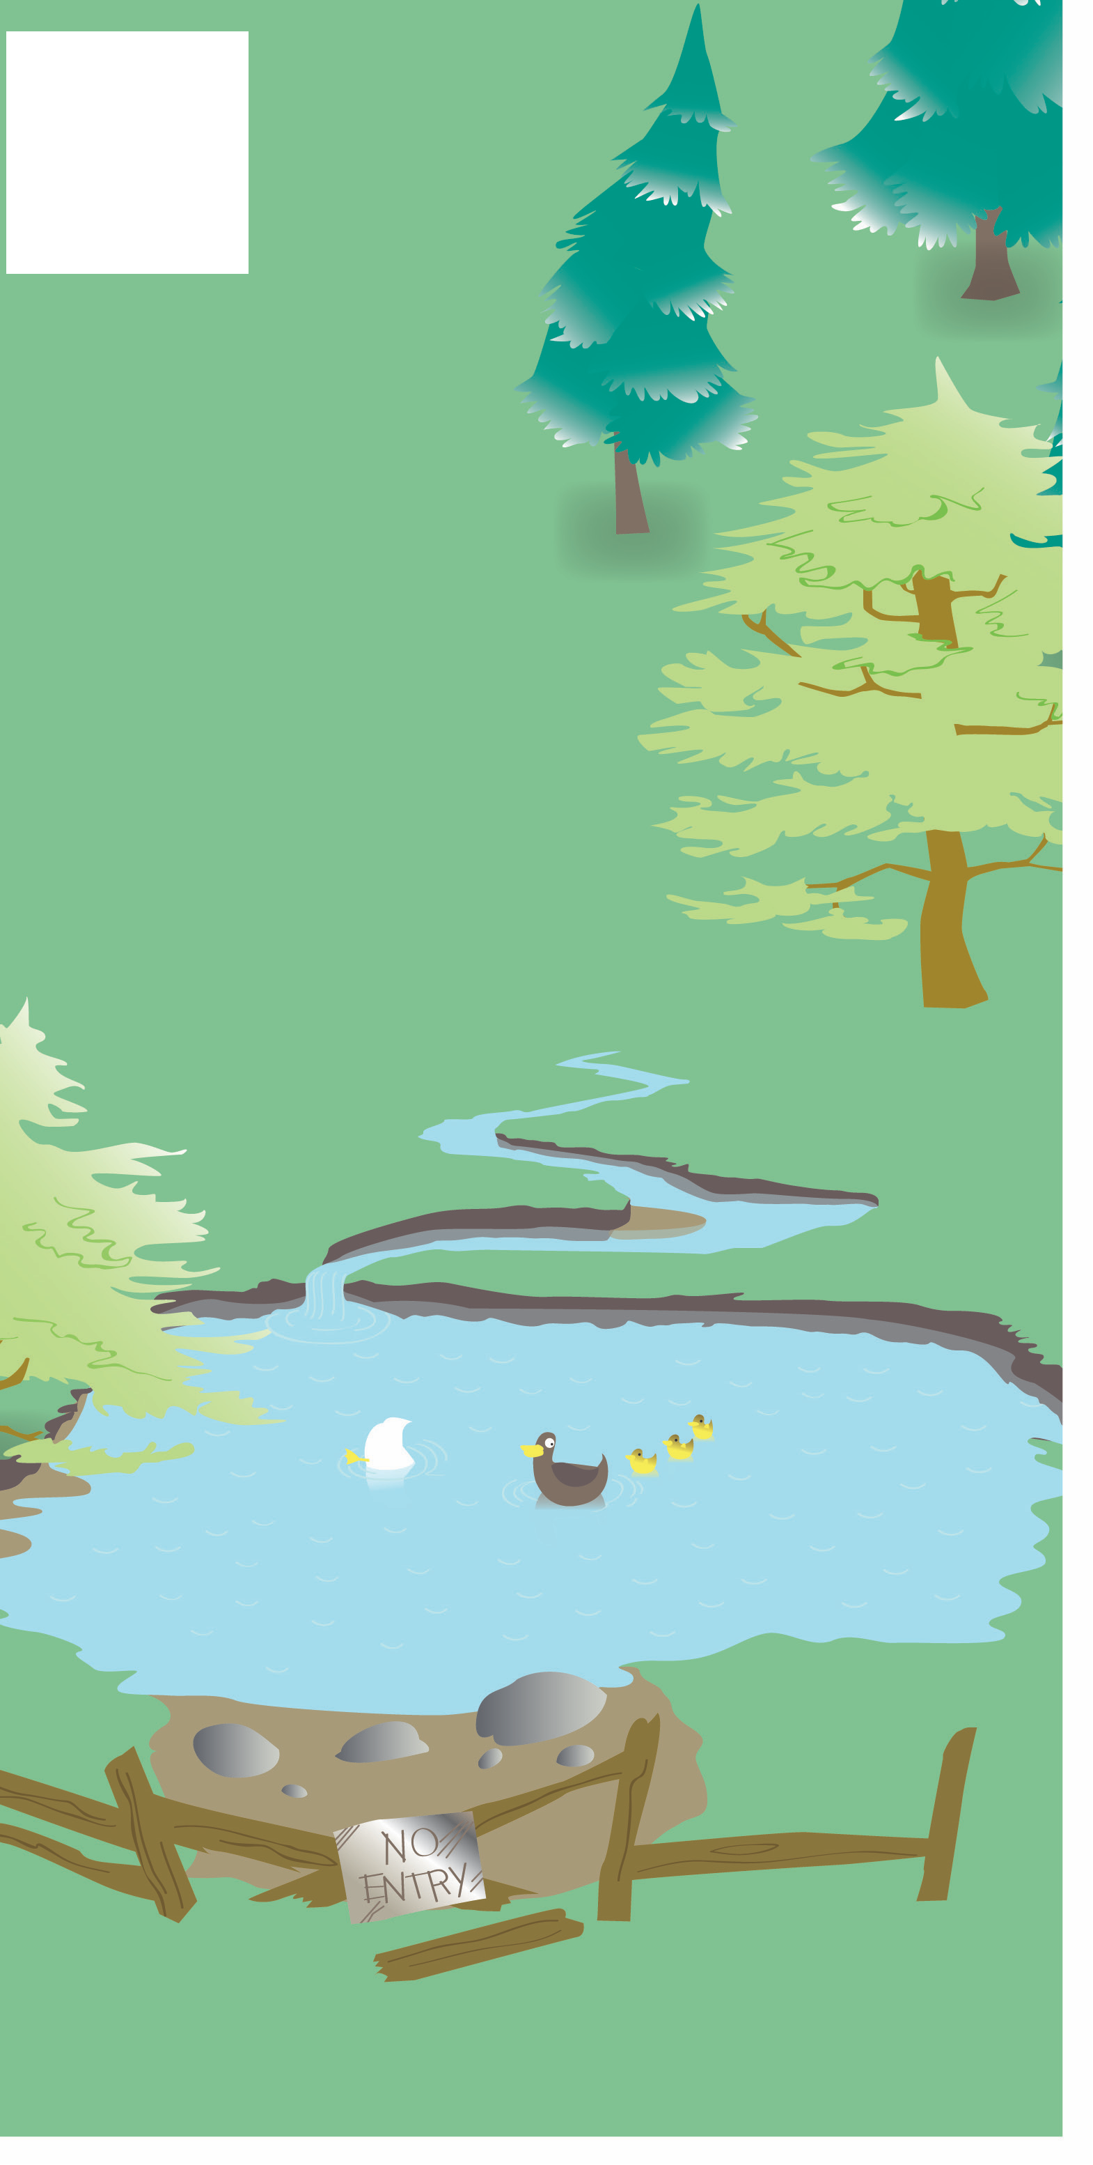Water
6

Farmers put up fences around rivers,
lakes and ponds to prevent animals
or children from falling into them. This also protects the water from getting dirty. Reeds and grass can often hide the edge of the pond so extra care is needed when walking through fields or wooded areas where there might be ponds. Be aware of any water on the farm. Do not walk, play or work too close to ponds, streams, wells
or rivers. If you see someone getting into difficulty, do not attempt to go into the water. Go to an adult for help or call 999. We should never litter
our waterways as it causes damage to our environment as well as our animals

Remember: Stay away from waterways on or near the farm.

