Can you fill in the names of the capital cities of Europe in the box below. The map will help.
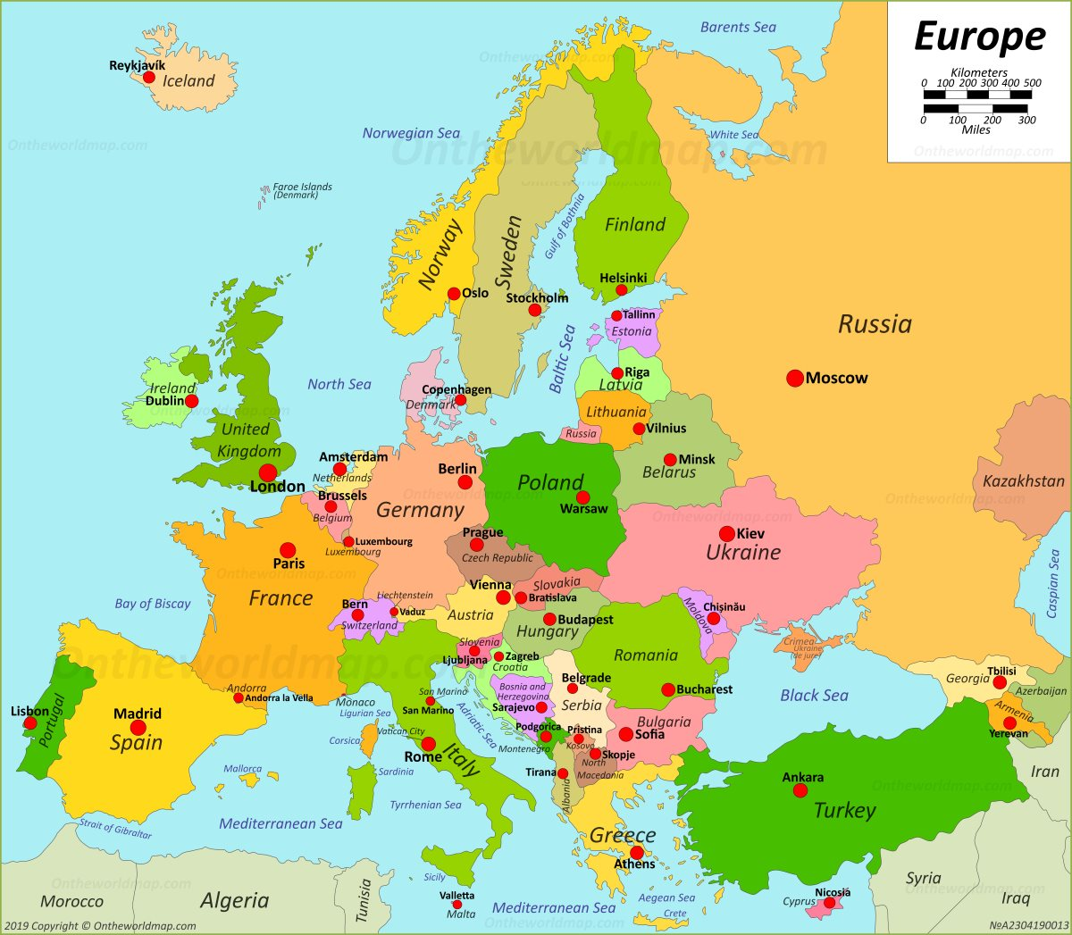
Ireland  Dublin | UK  London | Iceland | Russia  Moscow | Norway  Oslo
Sweden  Stockholm | Denmark  Copenhagen | Finland  Helsinki | France  Paris | Malta  Valetta
Spain  Madrid | Poland  Warsaw | Switzerland  Bern | Belgium  Brussels | Netherlands  Amsterdam
Italy  Rome | Greece  Athens | Germany  Berlin | Estonia  Tallinn | Serbia  Belgrade
Estonia  Tallinn (oops!) | Latvia  Riga | Lithuania  Vilnius | Belarus  Minsk | Ukraine  Kiev
Turkey  Ankara | Austria  Vienna | Bulgaria  Sofia | Romania  Bucharest | Croatia  Zagreb
Hungary  Budapest | Slovakia  Bratislava | Czech Republic  Prague | Albania  Tirana | Cyprus  Nicosia

