Can you fill in the names of the capital cities of Europe in the box below. The map will help.
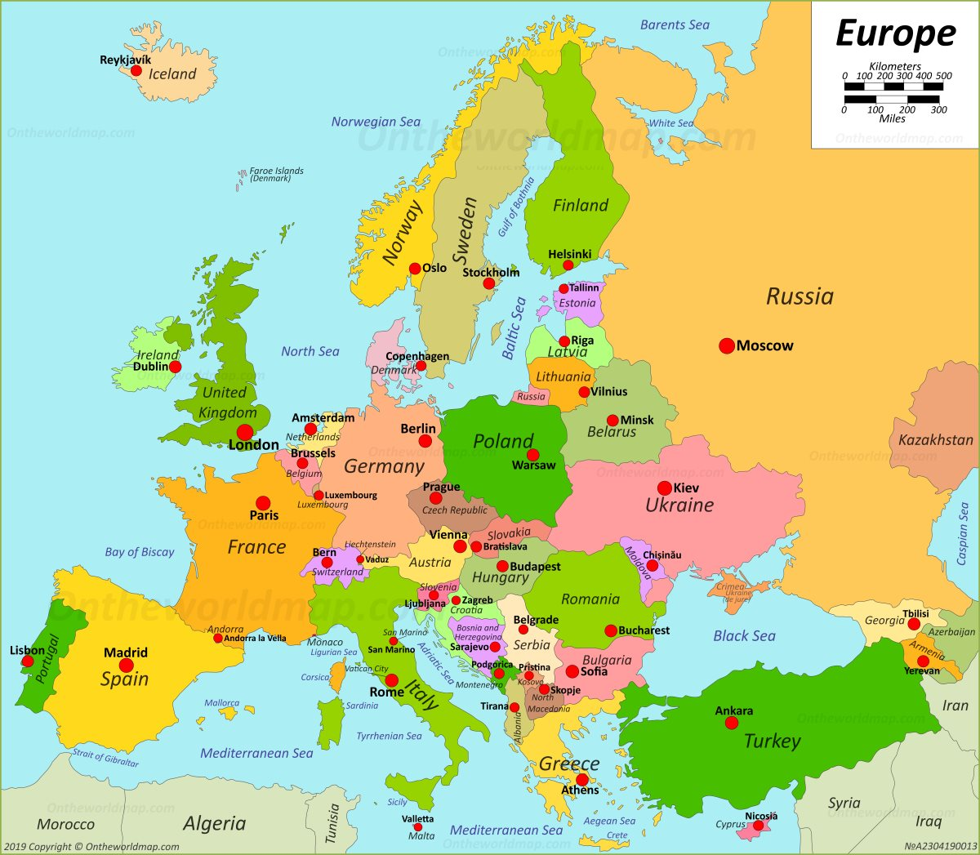
Ireland  Dublin | UK | Iceland | Russia | Norway
Sweden | Denmark | Finland | France | Malta
Spain | Poland | Switzerland | Belgium | Netherlands
Italy | Greece | Germany | Estonia | Serbia
Estonia | Latvia | Lithuania | Belarus | Ukraine
Turkey | Austria | Bulgaria | Romania | Croatia
Hungary | Slovakia | Czech Republic | Albania | Cyprus

